What happens after the Stroke / TIA Clinic

This pack is to provide you with information and contact details for you and your family after you have attended the Stroke / TIA clinic.

3-4 weeks after your attendance at the Stroke Clinic you will receive a follow up call from the Stroke Nurse Service. The nurse will check how you have been since attending the clinic, check that you are managing your medication, discuss your back to driving (where applicable) and answer any questions you have about your stroke /.TIA.

If you have any questions or anything that is worrying you then please get in touch with the Stroke Nurse on 01463 704086 or email: linda.campbell8@nhs.scot

If you think you are having a further Stroke or TIA please follow the FAST protocol:

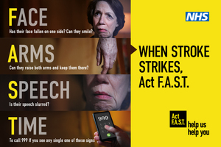

Where to get stroke information, support and advice

Stroke Specialist Nurse
Linda Campbell
Tel: (01463) 704086
Email: linda.campbell8@nhs.scot

Chest Heart and Stroke (CHSS) Advice Line
Telephone: 0808 801 0899
Mon- Fri, 9.30- 4.30pm

Stroke Association Advice Line
Telephone: 0303 3033 100
Mon-Sat, 9.00 – 4.30pm (may vary on Sat)

Carers Information

Stroke Specialist Nurse
Linda Campbell
Tel: (01463) 704086
Email: linda.campbell8@nhs.scot

Connecting Carers
Glen Orrin House,
High St,
Dingwall
IV15 9TF
Tel: 01463 723560
Mon-Fri , 9.00-4.00pm

Useful Websites
http://www.Stroke4Carers.org - this is for info for people who care for stroke and has some useful tips. Some of the video clips may not work as we are just updating some info

www.Selfhelp4stroke- this is useful to work through and set goals

https://www.stroke.org.uk/finding-support/my-stroke-guide- this is a self help guide for stroke that also has a chat forum

http://www.chss.org.uk - general stroke info
http://www.stroke.org.uk - general stroke info

