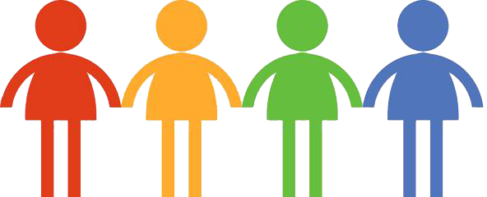



**Information for Young People**

**Version 20/07/21**

Your questions answered...

*.*

**What can you expect?**

* Speak with staff at your School, or Professionals you may already be involved with.
* Alternatively, you can contact us directly for advice by emailing [nhsh.nds@nhs.scot](mailto:nhsh.nds@nhs.scot) .
* You and your parent/ carer will be asked for permission:
* to give the NDAS team information about you
* to talk with the NDAS team
* for assessment to take place if needed.
* Usually a member of the NDAS team will then talk with someone from your school or your parent/ carer. They may talk to you as well.
* If it is agreed that an NDAS assessment may be right for you at that time, information about you is given to the team.
* A meeting is held where it is decided whether it would help you to be assessed by NDAS, and if so which professionals should do this.
* You and/ or your parents will be told what was decided. Questionnaires may be sent out if more information is needed.
* If an assessment is needed appointments could take place in a clinic and/ or on video link. School and home visits may also take place. Assessment will usually be with 2 adults from the NDAS team.

**How to access the service**

**Neurodevelopmental**

**Assessment Service**

**(NDAS)**

**Who is in the team?**

**How do I get support ?**

Speak with an adult at home or school who knows you well.

Useful information is available on [www.thrivingfamilies.org.uk](http://www.thrivingfamilies.org.uk/) (Phone- 07514 120288) and [www.thepineshighland.com](http://www.thepineshighland.com) .

You could also call ‘Just Ask’ on 0300 303 1365 any Tuesday or Thursday between 1pm - 4pm and a professional will call you back within a few days.

**What is the Neurodevelopmental Assessment Service?**

The neurodevelopmental assessment service is also called NDAS. The professionals in the NDAS team assess and diagnose children and young people who may have neurodevelopmental disorders.

Sometimes a diagnosis (the name for the difficulties) may be given, but not always.

The team includes these professionals:

* Community Paediatricians
* Speech and Language Therapists
* Occupational Therapists
* Clinical and Assistant Psychologists
* Specialist Nurses

The professionals you will see depends on your difficulties.

Professionals who know you just now or have known you in the past may be asked for information about you.

You, your parent/ carer, someone at your school, or a professional you know are wondering if you may have a neurodevelopmental disorder.

**Why have you been given this leaflet?**

**What is a neurodevelopmental disorder?**

Neurodevelopmental difficulties can affect children and young people’s development.

Difficulties may be found with things like:

* Looking after yourself
* Remembering things
* School work
* Organising things
* Getting on with other people
* Friendships and relationships
* How you feel about yourself
* Understanding and speaking with others
* Making sense of the world around you

What you are good at and what you have more trouble with may change as you get older. Some difficulties last longer and are more of a problem. This may be part of a disorder.

Disorders which may be diagnosed can include:

* Attention Deficit Hyperactivity Disorder (ADHD)
* Autism Spectrum Disorder (ASD)
* Developmental Coordination Disorder (DCD)
* Foetal Alcohol Spectrum Disorder (FASD)